Galderma Quarterly AKBCC Staging Area

User Documentation
Version 1.0


Contents
1 Document control 4
1.1 About this document 4
1.2 Changes made to this document 4
1.3 Purpose of this document 4
1.4 Audience for this document 4
2 Assumptions and constraints 5
3 Process 6
4 QC 10
5 Process 18
6 Appendix 19
6.1 Appendix A1: Download FTP Information 19
6.2 Appendix A2: Download Server Information 19
6.3 Appendix A3:Processing Server Information 19
6.4 Appendix A4:File Express Information 19

Document control

About this document
Author | Anika Nower
Published
File location
Status
Confidentiality | This document is confidential and must not be distributed outside of IMS Health.
Copyright | © 2026 IMS Health Incorporated or its affiliates. All rights reserved.

Changes made to this document

Version | Sections changed or created | Date of change | Author or contributor name | Role | Change summary
 |  | 10th June 2015 | Anika Nower

Purpose of this document
The purpose of this document is to describe Galderma Quarterly AK BCC Staging area.

Audience for this document
This document has been written for:
- Production team members

Assumptions and constraints

ID | Assumptions

ID | Constraints

Process
Step# | Step Description
Sample mail
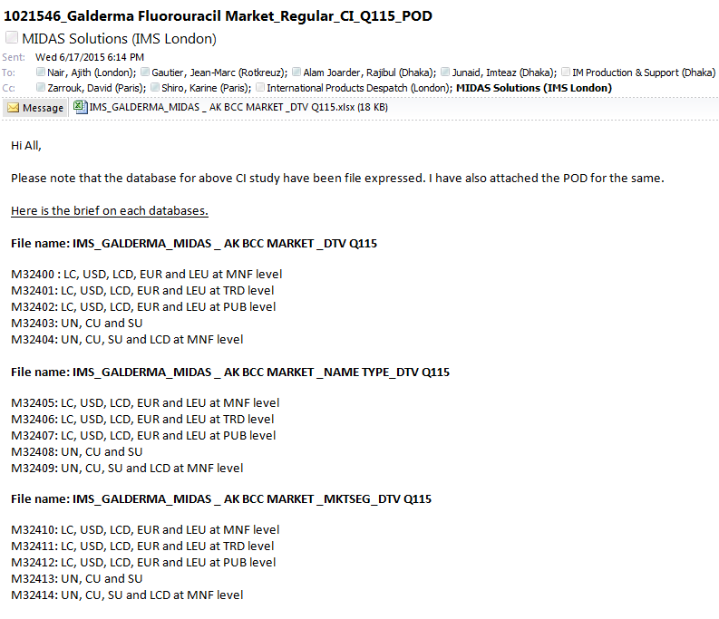
Log in to server to download the input file using
162.44.12.72
User name : PINASVC-IMAdmin
Password: !nf0_MgmT

Open IE , and goto http://www.imsportal.com/
Login with
id :: RAlamJoarder@bd.imshealth.com
Password:: centr1n0
 | Select Favorite Products →IMS File Express Administration → IMS File Express Menu →IMS File Express
Download in desktop folder galderma and copy the file to
G:\ftproot\Dhaka_DataFeed\galderma

 | Log on to the server using Appendix A3 (162.44.22.161)
From \\162.44.12.72\g$\ftproot\Dhaka_DataFeed\galderma copy the input files and paste. Unzip the file using Extract to folder.
Go to D:\CustomData\Galderma_midas_feed\Input\Monthly\Monthly New Contract
rename NEW_IMS_GALDERMA_MIDAS _DTV M0415 to REVNO
NEW_IMS_GALDERMA_MIDAS _MKTSEG_DTV M0415 to MKTSEG
NEW_IMS_GALDERMA_MIDAS _NAMETYPE_DTV M0415 to NAMETYPE
 | Each folder contain 8 zip file. Usually last need to be delete. Please check in mail, which zip file need to be delete.
 | Unzip the file using Extract to folder.
Rename the file
- Check which file include UN, CU, SU only from mail. Rename with M01
- Check which file include USD,LCD & LC – MNF Level from mail. Rename with M02
- Check which file include EURO & LCE –MNF Level from mail. Rename with M03
- Check which file include USD,LCD and LC - TRD Level from mail. Rename with M04
- Check which file include EURO & LCE - TRD Level from mail. Rename with M05
- Check which file include USD,LCD & LC – PUB Level from mail. Rename with M06
- Check which file include EURO & LCE – PUB Level from mail. Rename with M07

Go to location
D:\PADDS Convert Tool\Convert50
Open convert.exe
1.Click analyze from menu bar.
2.Browse source file mask: D:\CustomData\Galderma_midas_feed\Input\Monthly\Monthly New Contract\REVNO\M01
3.Select .PRM file and open
4.Select Monthly
5.Click Scan Directory
6. Check Export headers, Norm. Periods
7.Click Edit Hierarchies
8. Delete all .DLL file
Delete all Additional Description
Except: PRD and PCK (Without LDATE delete other additional description.)
 | Click ok
 | Click convert→ yes
- on | One massage will show with the last line ready.
 | Close Hierarchies, close window.
 | For M02,M03,M04,M05,M06,M07 follow same step.
 | Rename .out file to foldername.txt
Backup the Output text file and zip file in a folder named with the latest period at-
D:\CustomData\Galderma_midas_feed\Output\Monthly\Monthly New Contract\Old
Go to D:\CustomData\Galderma_midas_feed\SSIS\galderma_midas_feed_New_Contract
Open galderma_midas_feed_MTH_REVNO.sln
Run QTR New contract REVNO.dtsx
Output file IMS_GALDERMA_MIDAS_FF_Qqyy_REVNO.txt will generate in location D:\CustomData\Galderma_midas_feed\Output\quarterly\Quarterly New Contract
Rename the file with latest time period
Zip the file
 | Same process goes to NAMETYPE REVNO and MKT REVNO (step 13 - 22)
SSIS package for NAMETYPE: QTR New contract Nametype REVNO.dtsx
MKT : QTR New contract MKTSEG REVNO.dtsx
For delivery:
Zip the output txt file.
Copy output zip file and QC zip file to \\162.44.12.72\g$\ftproot\Dhaka_DataFeed\galderma

 | Login: 162.44.12.72
Select Favorite Products →IMS File Express Administration → Add new file→browse select the output zip file.
Template :Galderma
File description: New contract delivery for Qqq/yy REVNO
Save all.

QC
1 | Copy:  Book2.xls  IMS_GALDERMA_MIDAS_FF_VALIDATION_MAT_Q115_REVNO_FINAL.XLS  IMS_GALDERMA_MIDAS_FF_VALIDATION_QTR_Q115_REVNO_FINAL.XLS  files from previous month folder to  D:\CustomData\Galderma_midas_feed\Input\Quarterly\Quarterly New Contract
2 | Steps of QC:  Step 1: open IMS_GALDERMA_MIDAS_FF_VALIDATION_QTR_Q115_REVNO_FINAL.XLS  And Book2.XLS
3 | Open .prm file from REVNO Q01 folder. See screenshort below:
 | 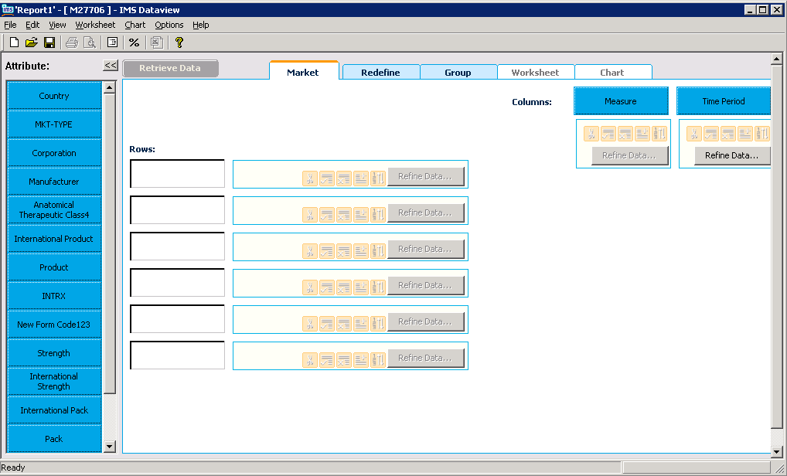
4. | Click “Country”,. Click “Add all” and then “OK”. See screenshot below:
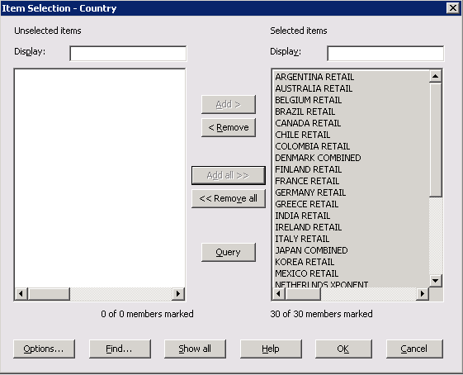
Click “Redefine Data” . Select “Ascending” and “Alphabetic” and click OK. See screenshot below:

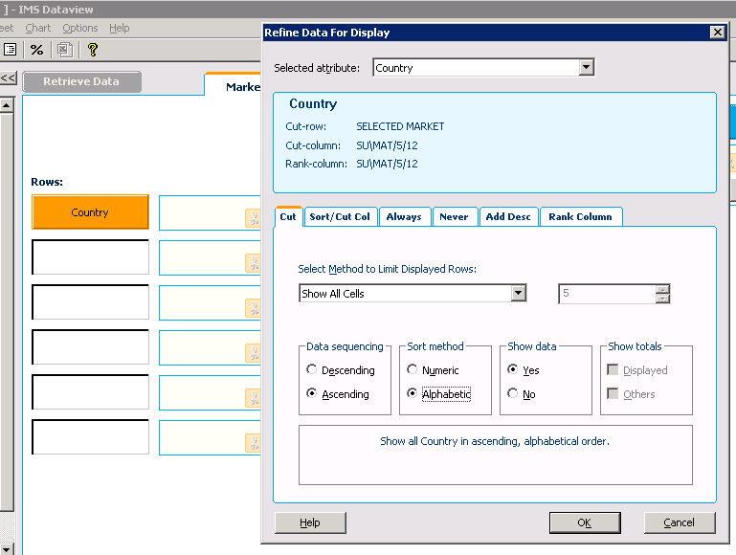
5. | Click “Measure”,. Click “Add all” and then “OK”. See screenshot below:
 | 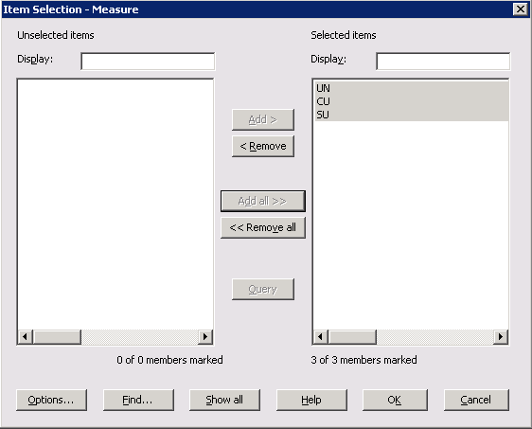
6. | Click “Period”, select latest month from the list. Click “Add” and then “OK”. See screenshot below:
 | 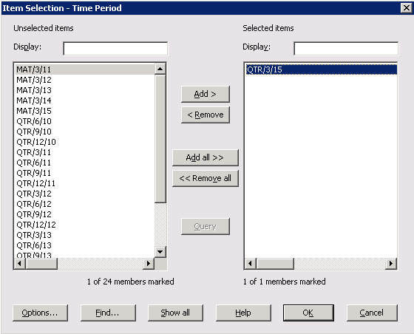
7. | Click “Retrieve data”,. Then copy the value from dataview
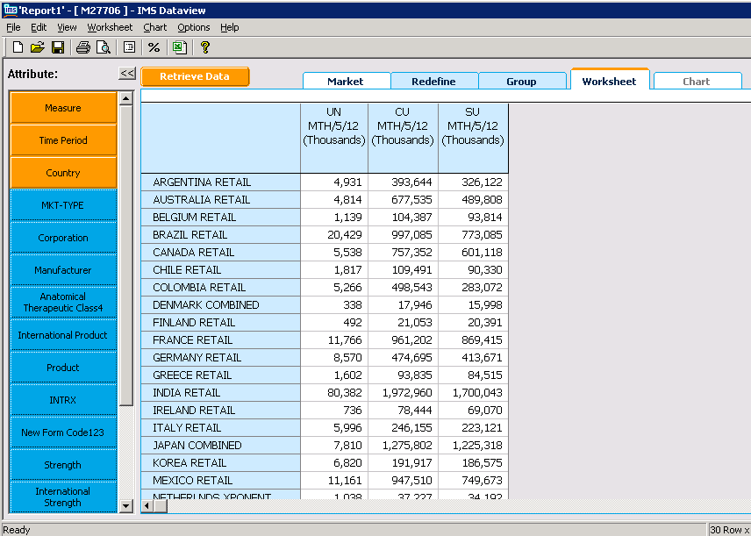
And paste in Book2.xls (sheet1) then copy the data with maintaining sequence of measure in IMS_GALDERMA_MIDAS_FF_VALIDATION_QTR_Q115_REVNO_FINAL.XLS dataview sheet. See the screen short below:
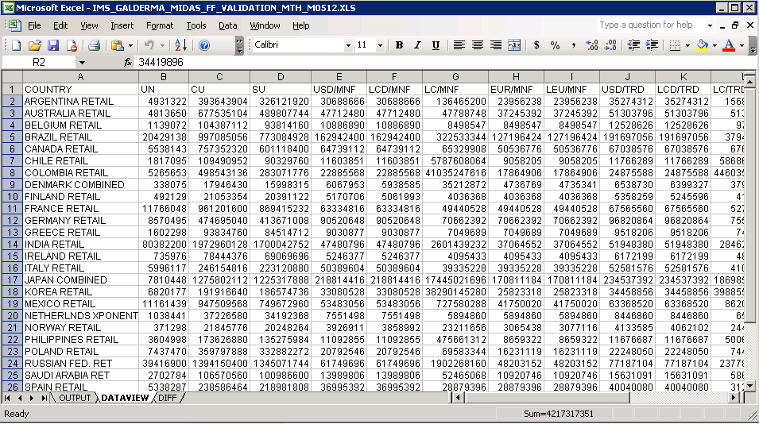
8 | Now fetch data with Mat1 and paste in Book2.xls Mat1 top portion. Do this for Mat2 to Mat5.
8 | Repeat this 3 to 7 for Q02 to Q04
9 | Now log on to SQL Server 2005
10 | Run QTR_QA_NewContract.sql from D:\CustomData\Galderma_midas_feed\Tools\SQL
11 | Paste result into output sheet in IMS_GALDERMA_MIDAS_FF_VALIDATION_QTR_Q115_REVNO_FINAL.XLS
12 | Check DIFF page that Diff should be 0.0000%
13 | Step 2: open IMS_GALDERMA_MIDAS_FF_VALIDATION_MAT_Q115_REVNO_FINAL.XLS
14 | Copy Mat1 top portion from Book1.xls and paste in Mat1 sheet top portion
15 | Copy Mat2 last portion from Book1.xls and paste in Mat1 sheet mid portion with paste special values.  Mat1 sheet last portion diff should be 0.0000%.
16 | Repeat this step for Mat2 to Mat5 for IMS_GALDERMA_MIDAS_FF_VALIDATION_MAT_Q115_REVNO_FINAL.XLS
17 | ZIP: IMS_GALDERMA_MIDAS_FF_VALIDATION_QTR_Q115_REVNO_FINAL.XLS and IMS_GALDERMA_MIDAS_FF_VALIDATION_MAT_Q115_REVNO_FINAL.XLS  Into IMS_GALDERMA_MIDAS_FF_VALIDATION_Q414_REVNO_FINAL.zip

5 Process

The table below lists other materials that are relevant to this document.
Title | Author | Version | Date | Location

Appendix

Appendix A1: Download FTP Information
Key | Value
FTP Server: | ftp-emea.rxcorp.com
Username: | D08044
Password: | CHProd
Location: | /Level1 PTRi/Client/Respective Month Name

Appendix A2: Download Server Information
Key | Value
Server Address: | 162.44.12.72
Username: | PINASVC-IMAdmin
Password: | !nf0_MgmT

Appendix A3:Processing Server Information
Key | Value
Server Address: | 162.44.22.161
Username: | DACASVC-GDCRDPAdmin
Password: | Wh2t3v3r

Appendix A4:File Express Information
Key | Value
URL: | www.imsportal.com
Username: | ijunaid@bd.imshealth.com or RAlamJoarder@bd.imshealth.com
Password: | B1hanga or centr1n0

